05/23/23 Meeting Notes

* This week, we finished labeling most of the fruit images; I believe Giffin still has some tasks in progress in Roboflow, but I believe most of the fruits are already labeled.
* I went ahead and trained a model using only images of the fruits, which gave us the following results, which I believe are very promising:

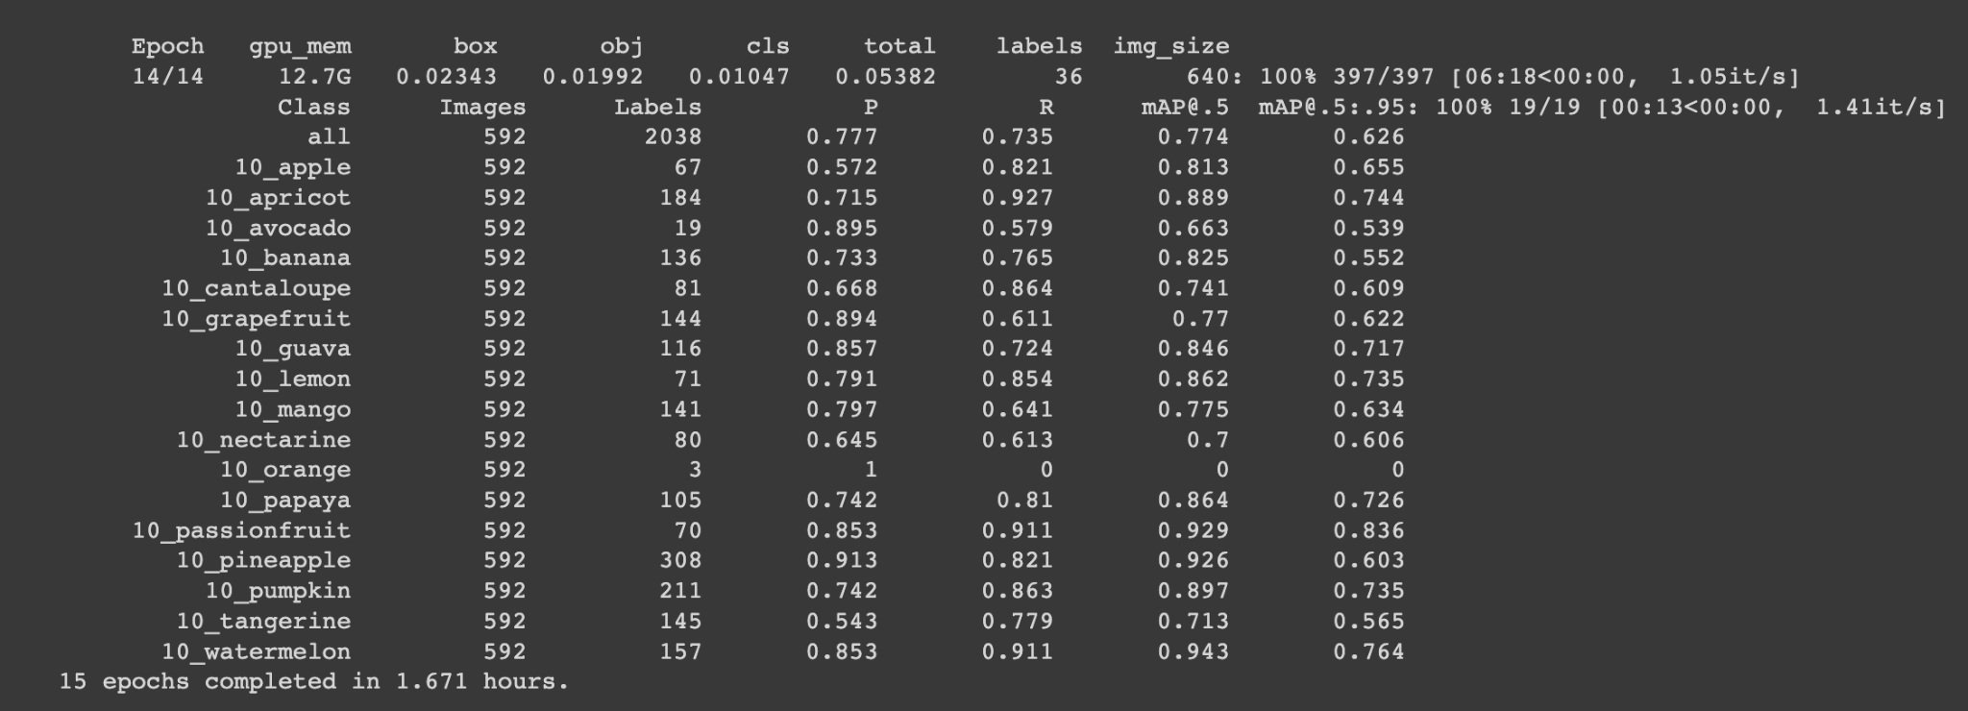

* For only 15 epochs of training, I believe we have a very high precision and recall for our fruits. We focus on the probabilities in the P and R columns, as these are the indicators of how well our model performs. There are some images like this one below, where I don’t fault the model, as even a human would have trouble differentiating between whether they are apricots or nectarines. I don’t think we can fault the machine here, as even I had trouble at first figuring out whether or not the fruits were nectarines or apricots. In most cases however, the model is able to properly identify fruits within images, and I believe that it is a promising start for our fruits.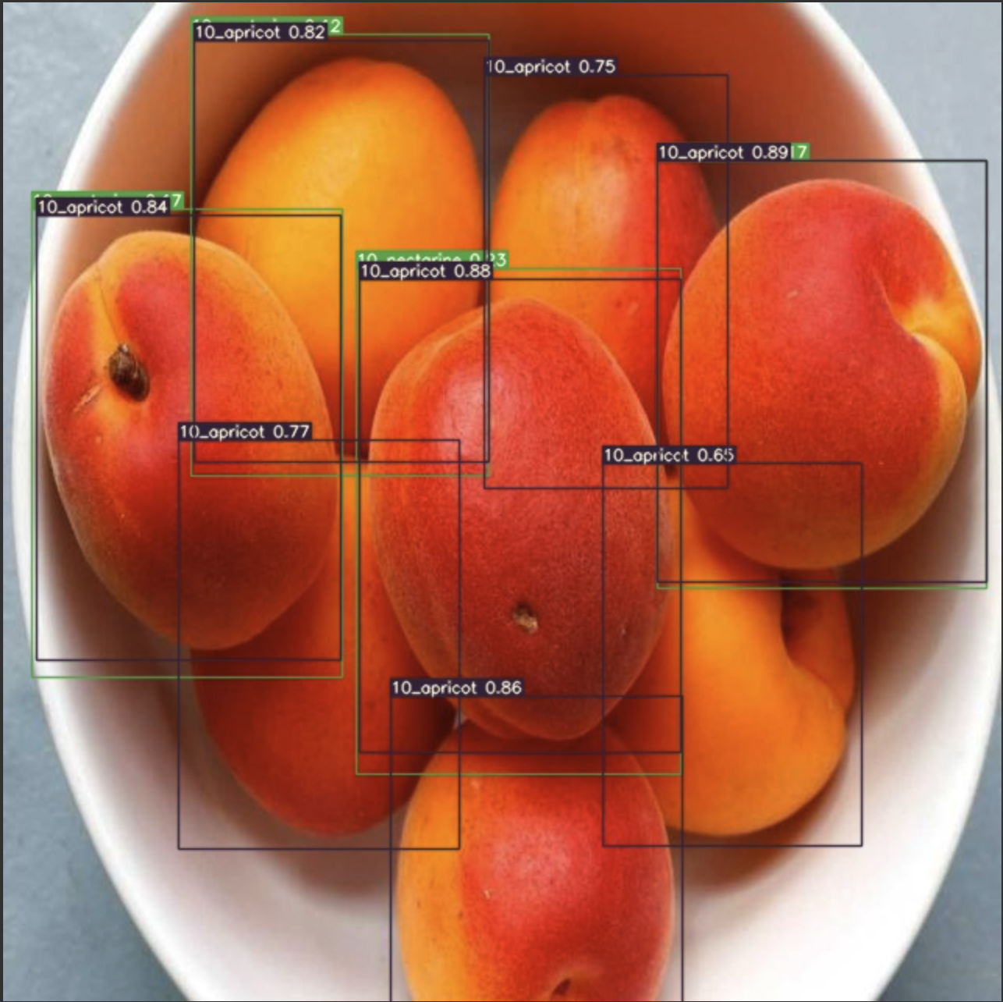
* For future reference since we are presented with a set of probabilities by the model of which food it believes is in the model, we can use some sort of cutoff for the probability when determining between which bounding boxes to take as the true box. For example, in this image, one box only has probability of 0.12, and so it would be in our best interest to maybe remove this one and use the other box, but this is something that we can implement later.